Home Page

CHANGES

Change all the texts and fonts and size everywhere, throughout the code. ]

Change the strip of green color to Blue
And change all the texts present on the strip to black and all the logos too

Change the tab buttons to blue color (tab in the sense HOME, FURNITRUE BUTTONS) and LOGIN BUTTON ALSO.

Change “Online Furniture Store Management System” to black color.
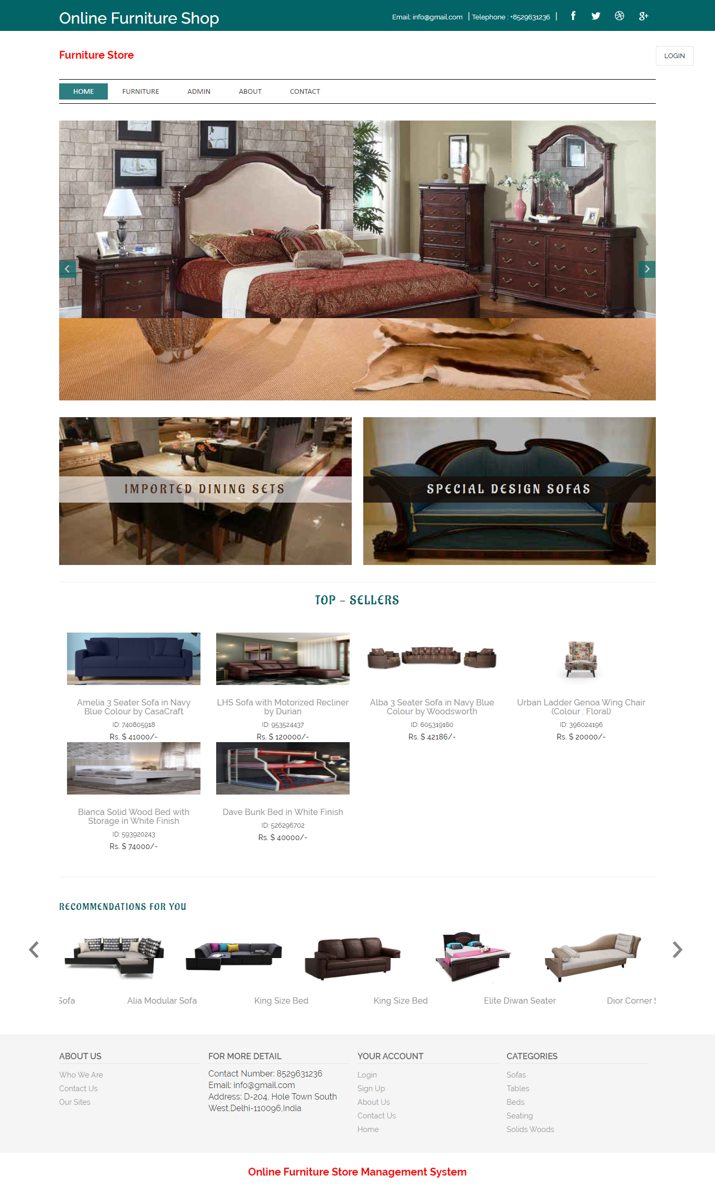

Products View

CHANGES

Change the dollar symbol to rupee sign.
Change green color to blue everywhere.

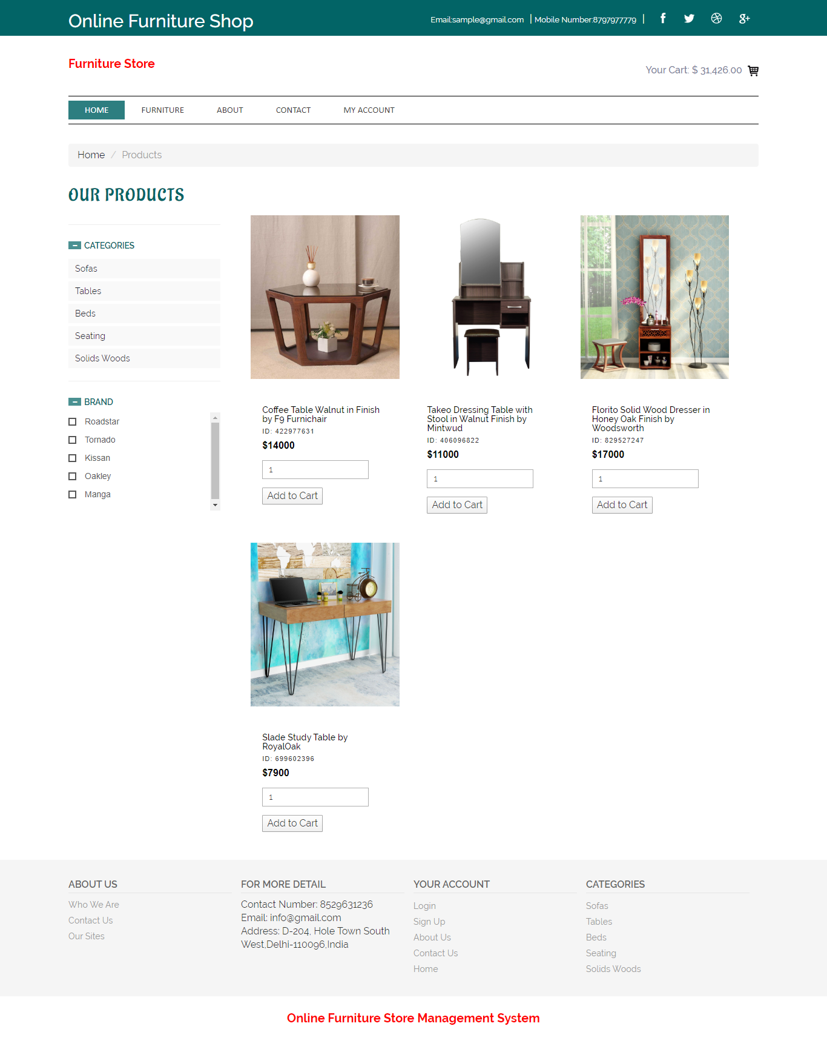

About Us

CHANGES

Change color of ABOUT US TO BLUE.

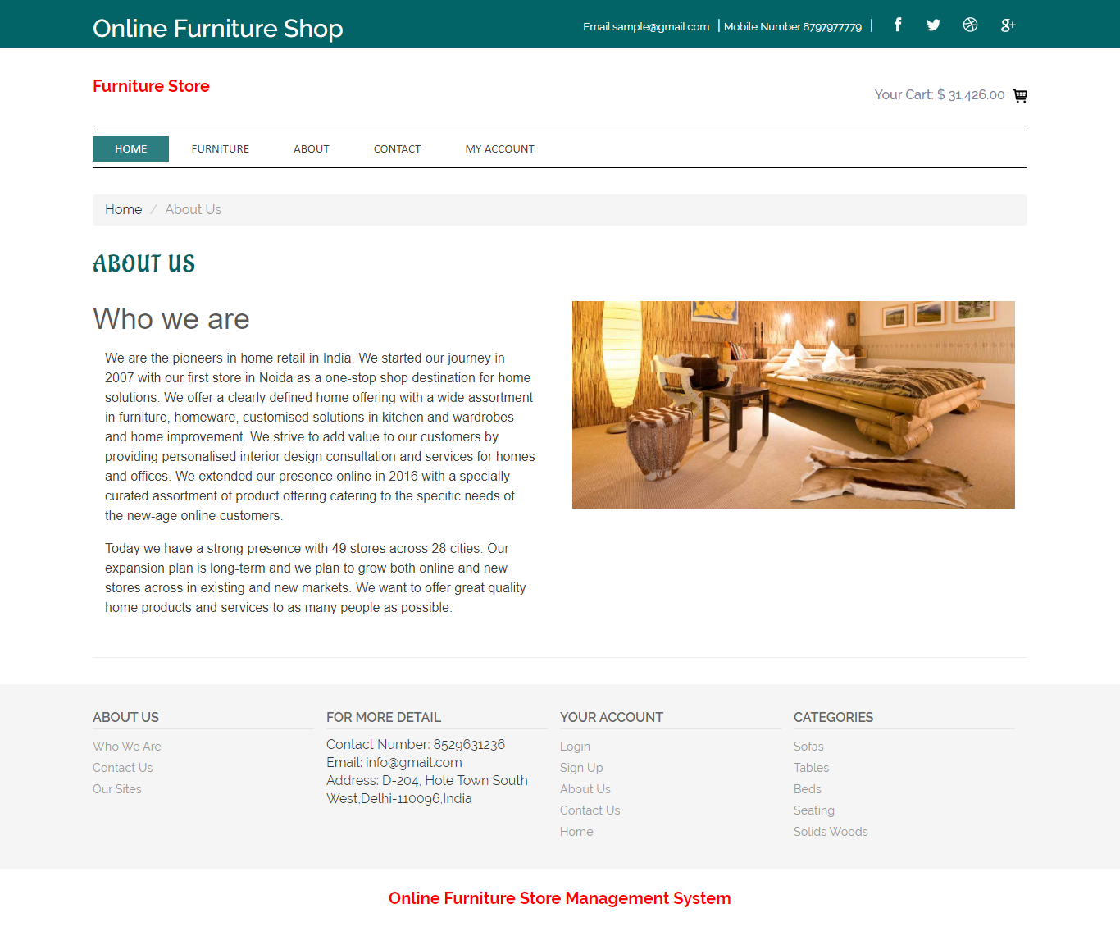
Contact Us

CHANGES

Change CONACT US to blue color.
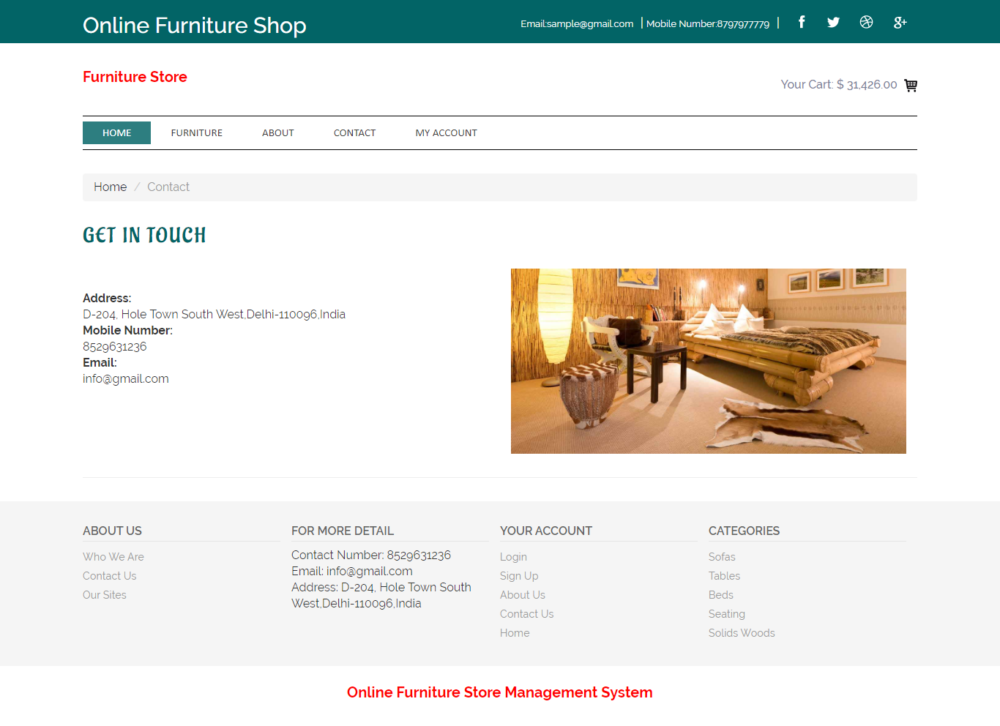

User Profile

Same BLUE EVERYWHERE.
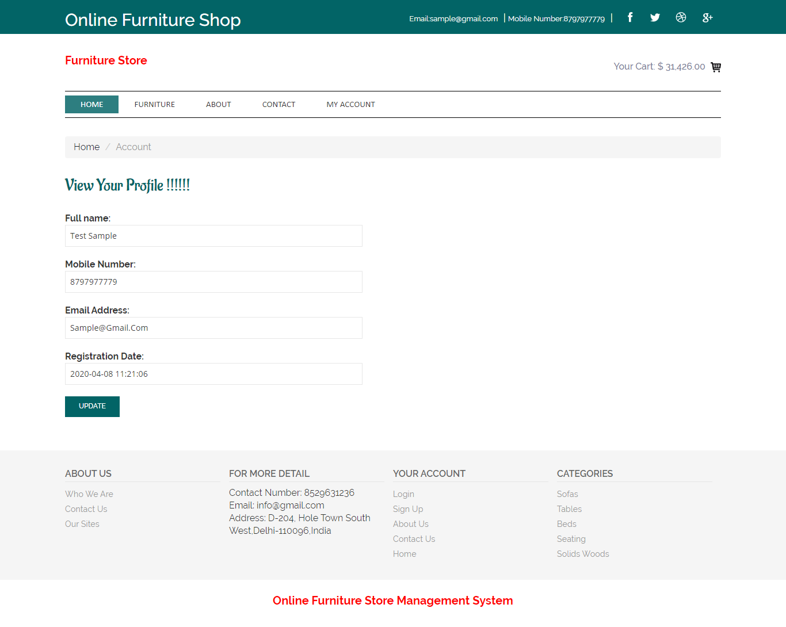

Change Password

BLUE EVERYWHERE
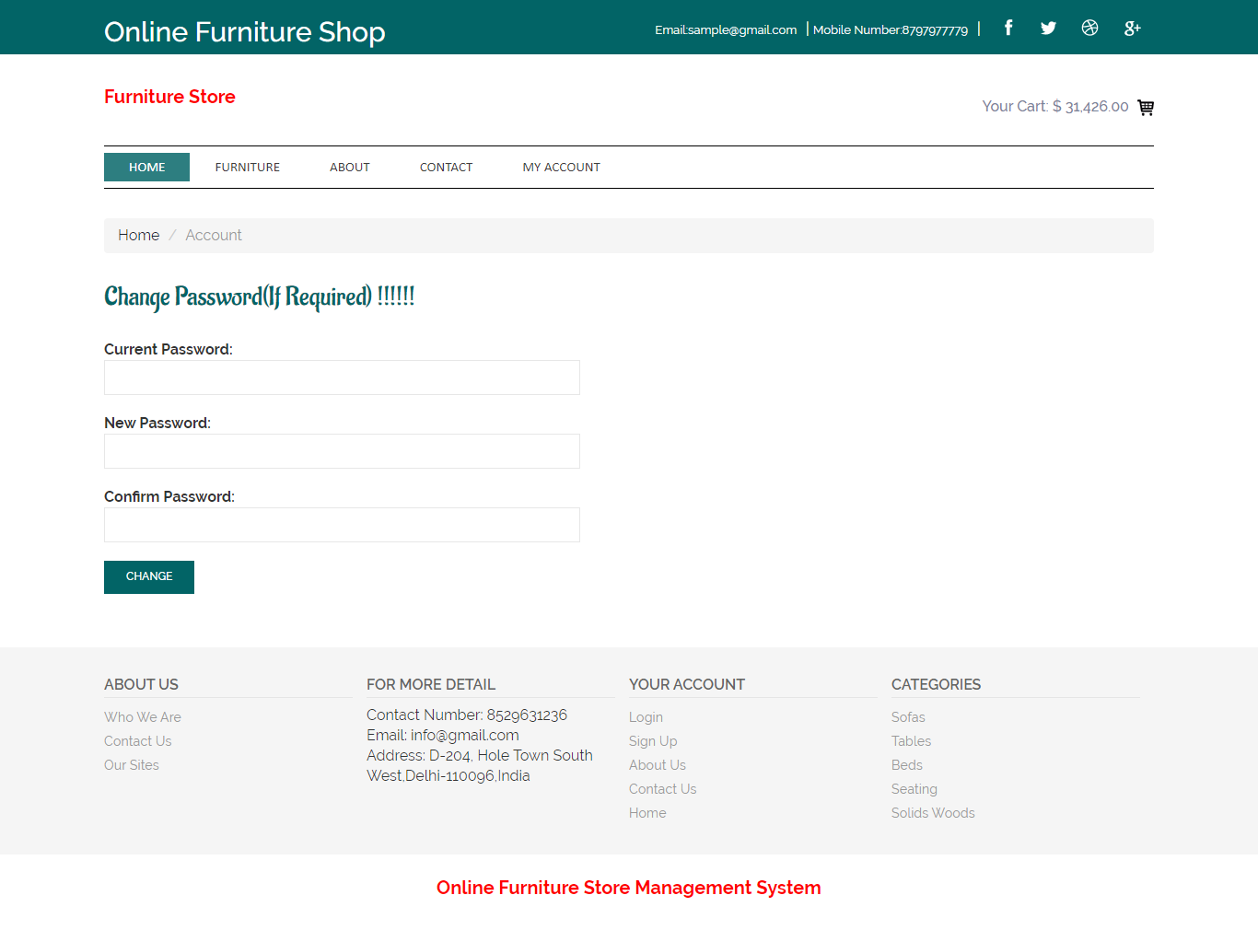
My Cart

CHANGE DOLLAR SIGN TO RUPEE.
CHANGE “CHANGE TO BASKET BUTTON” TO BLUE COLOR.

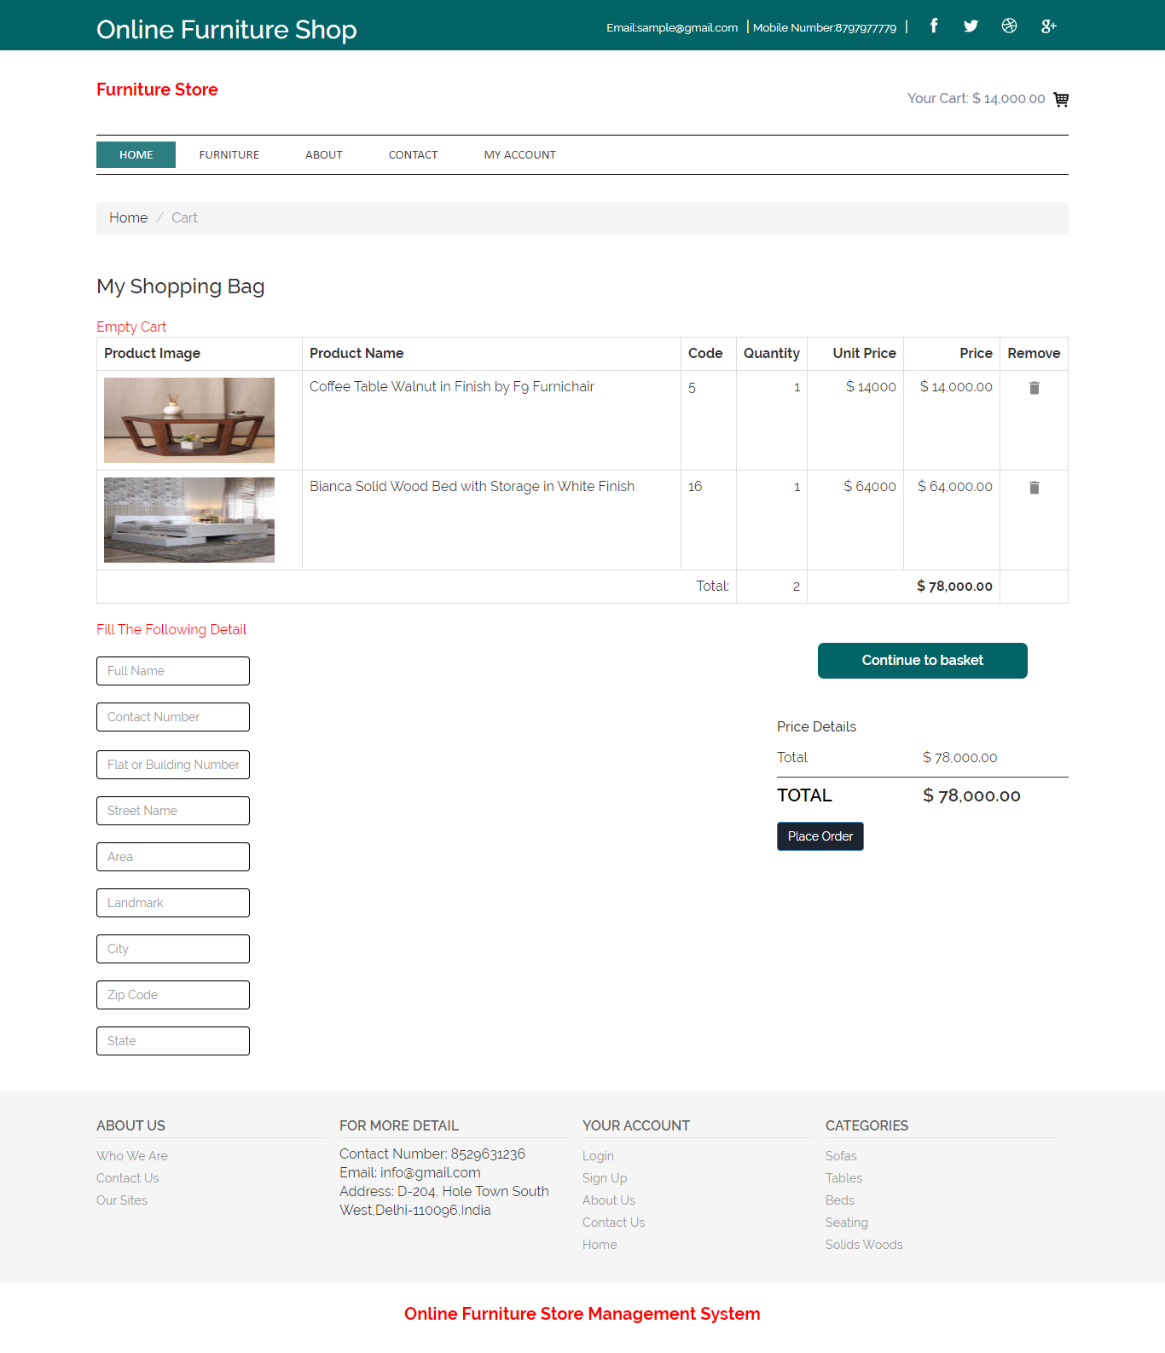

Order Detail Page
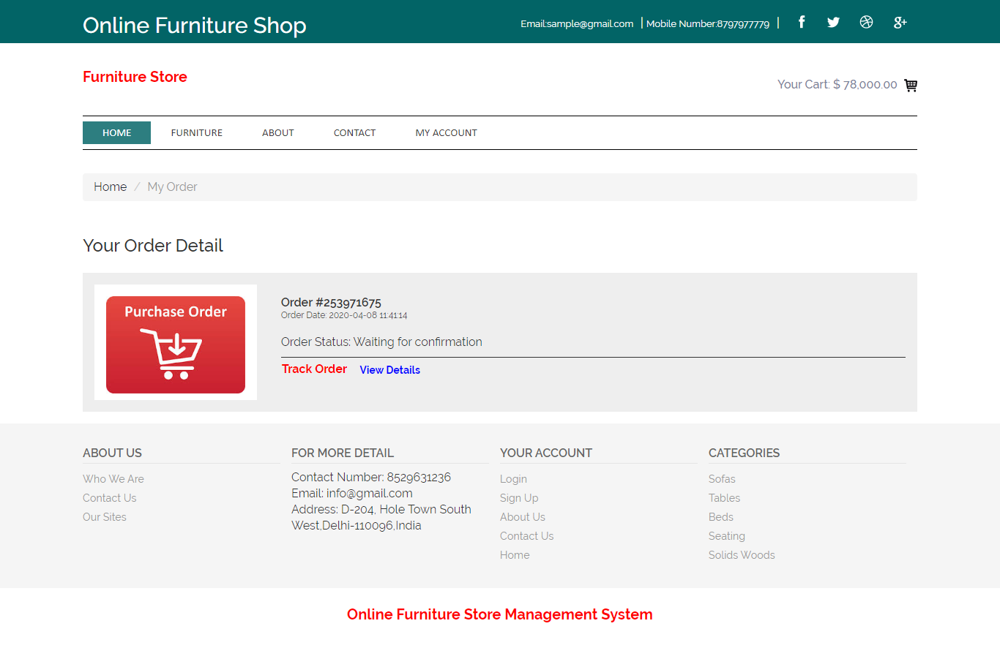

View Single Order Detail

CHANGE ORDER DETAILS TO BLUE COLOR.
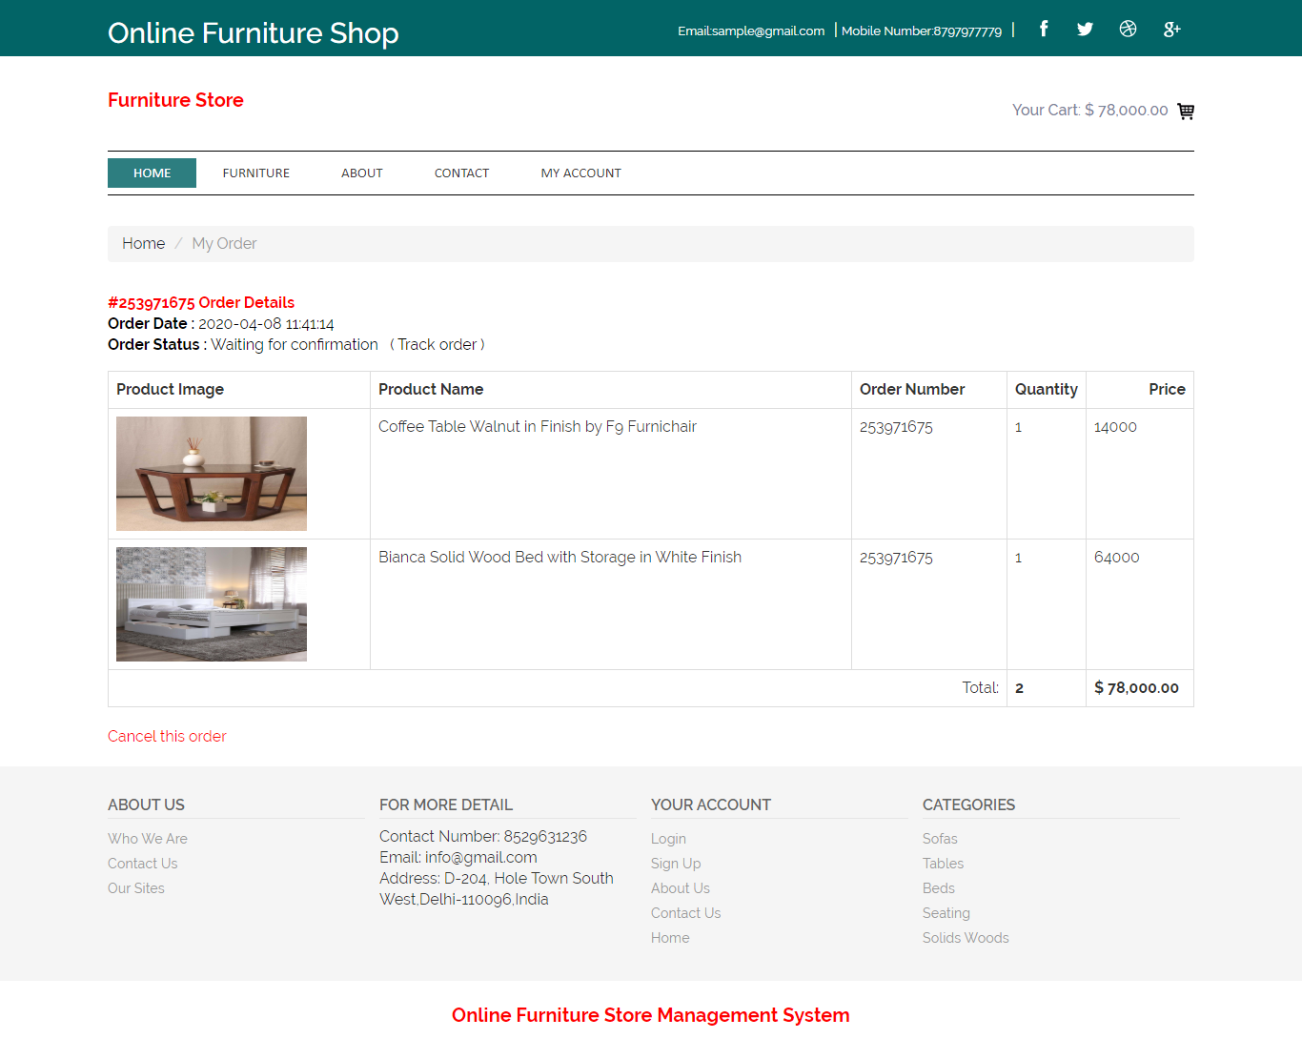

Cancel Order Page

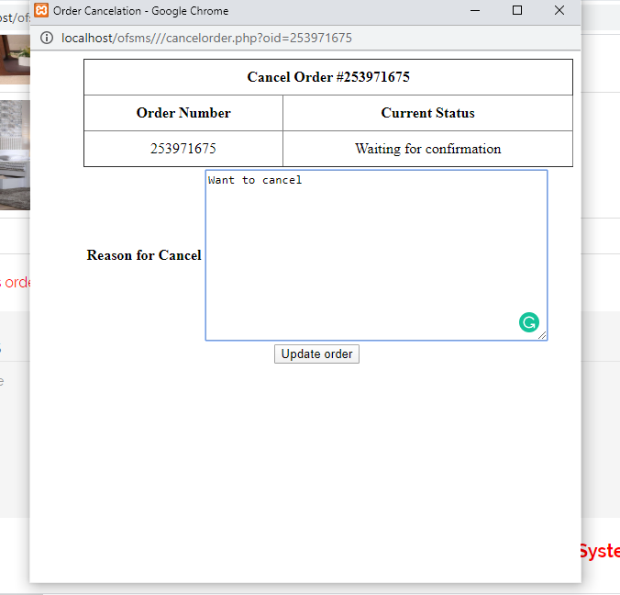

Single Product Page
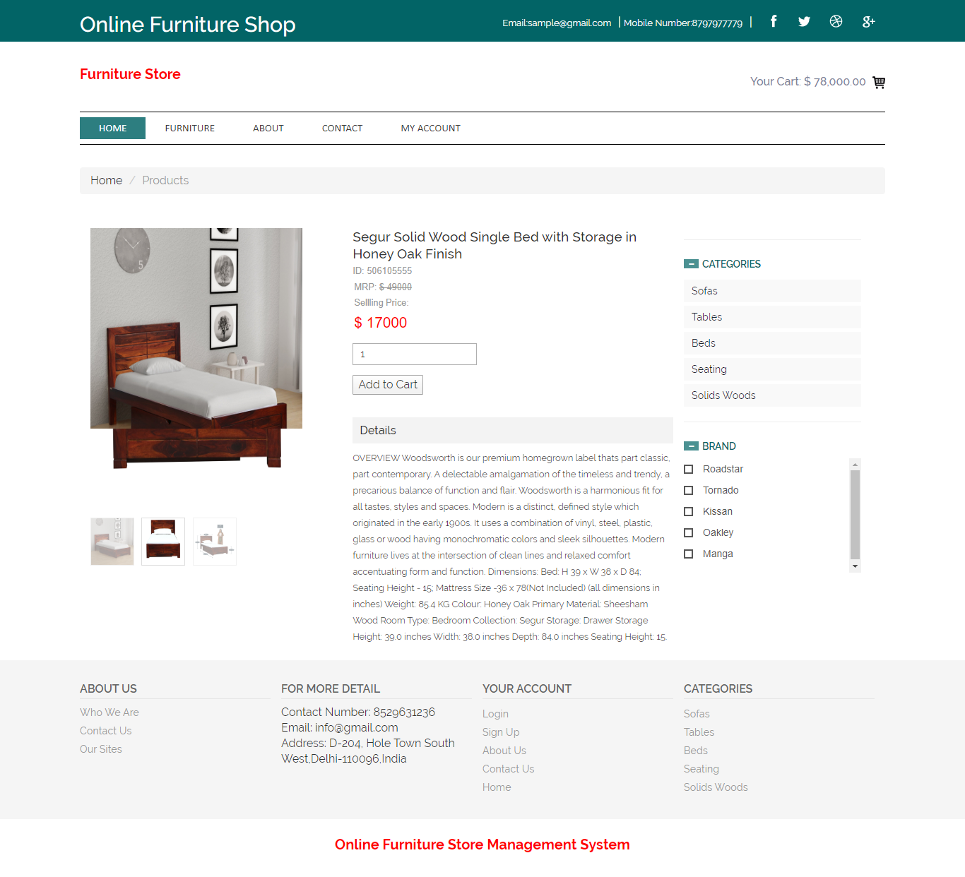
Signup/Login Page
CHANGE EVERYWHERE TO BLUE COLOR

EVEN THE CREATE ACCOUNT BUTTON AND SIGN IN BUTTON.

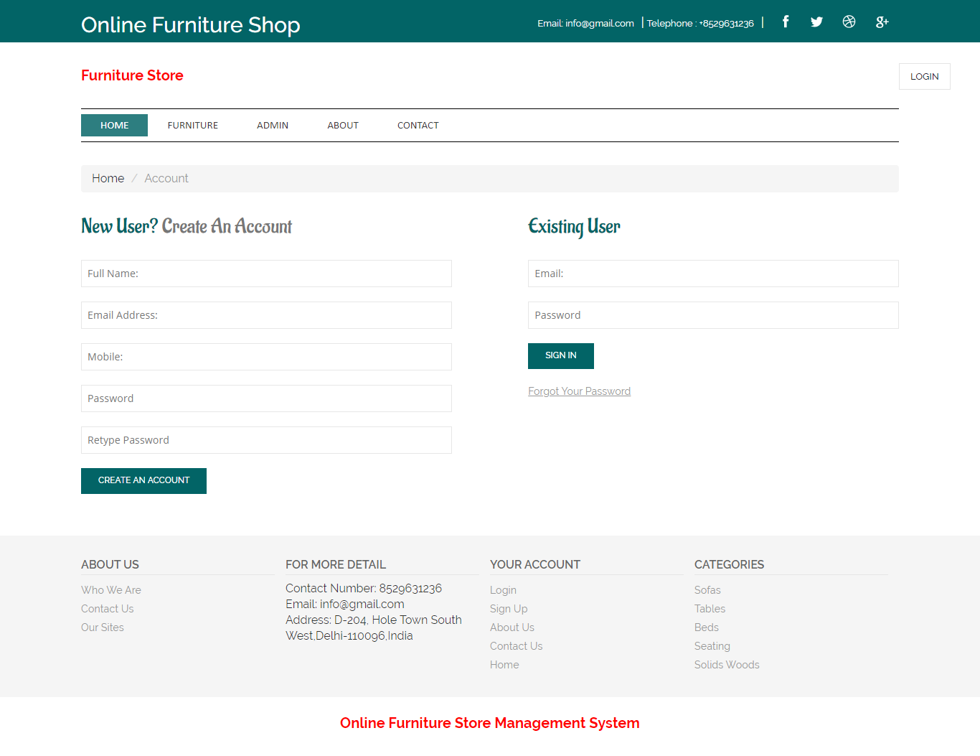

Forgot Password
SAME DO BLUE EVERYWHERE
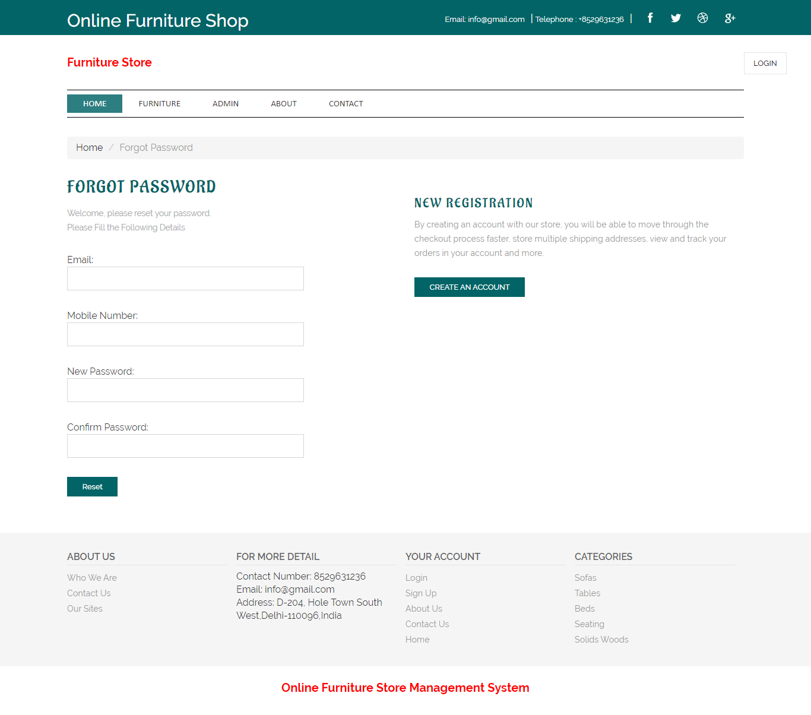

Admin Login Page

CHANGE COPYRIGHT TO 2023
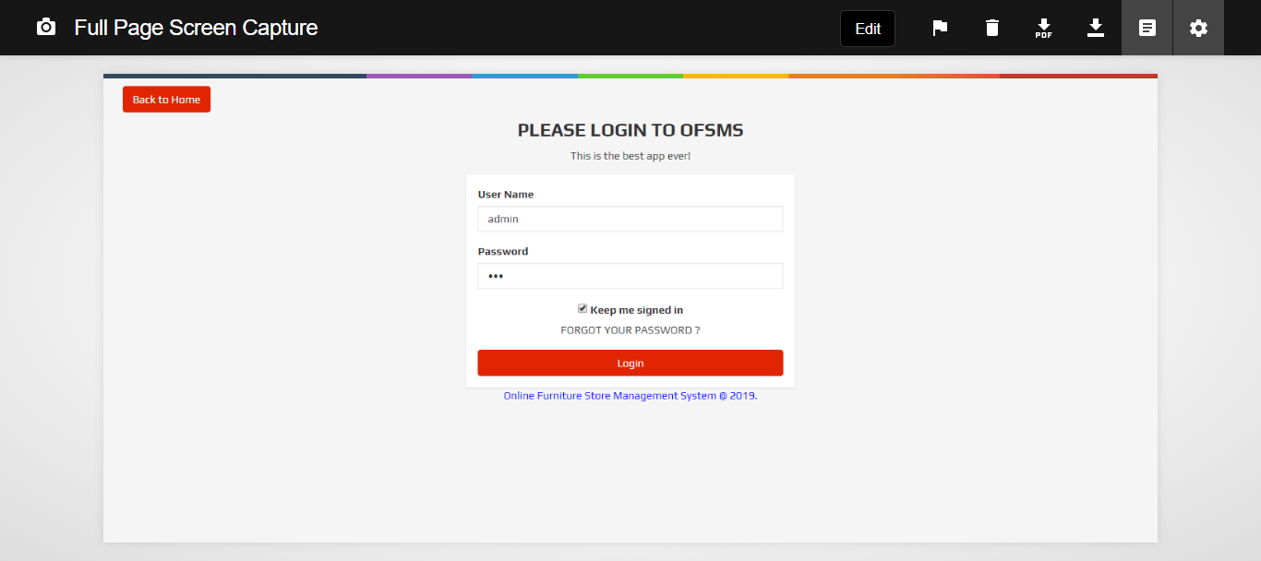

Dashboard

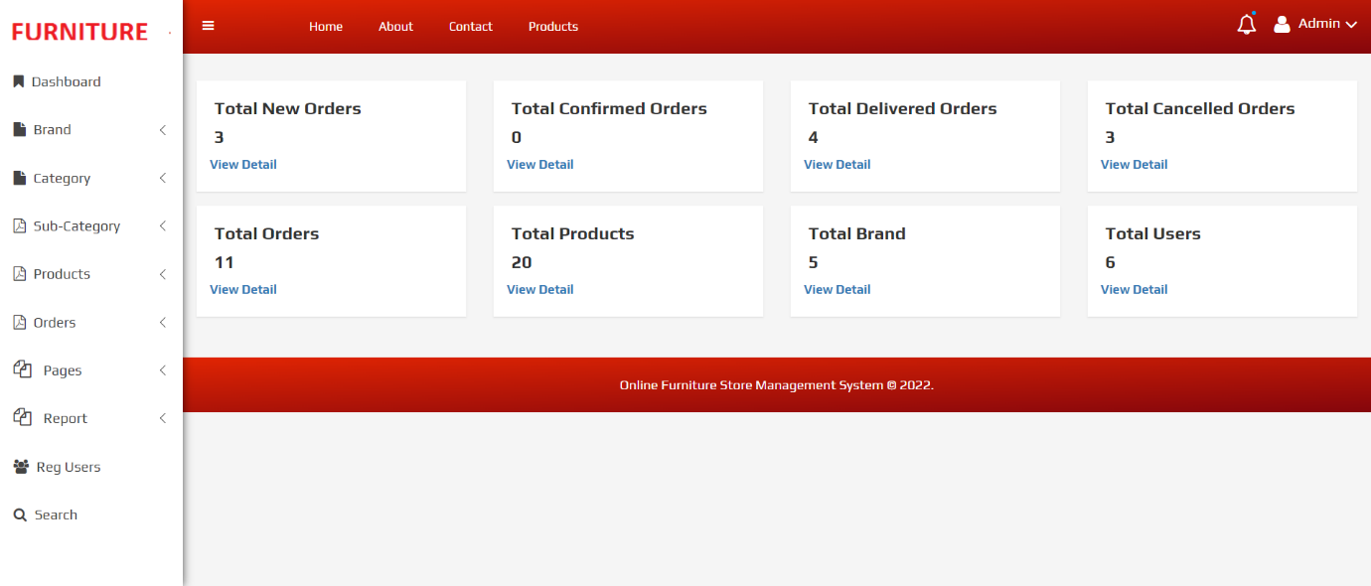

Admin Profile
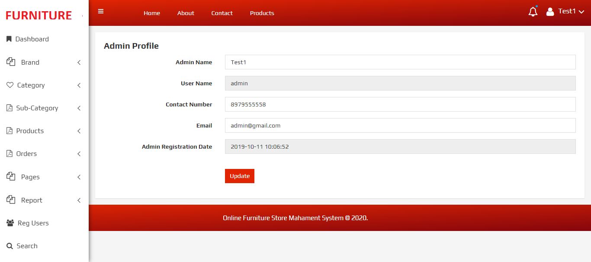

Change Password
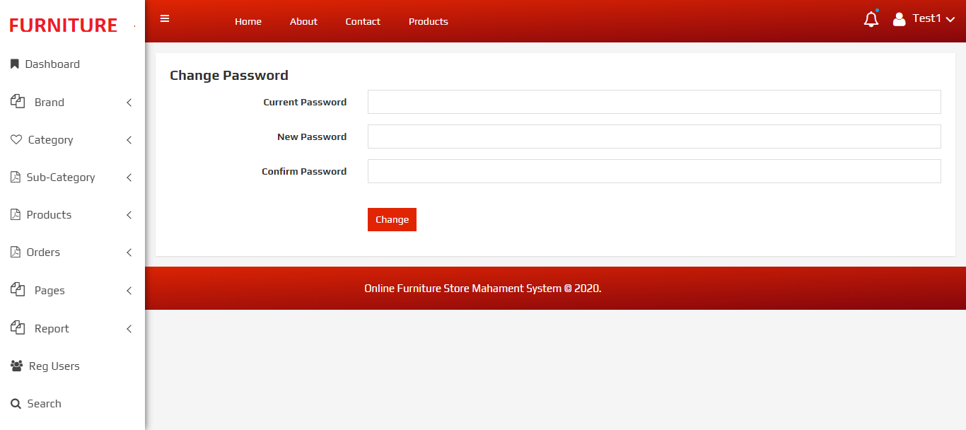

Add Brands

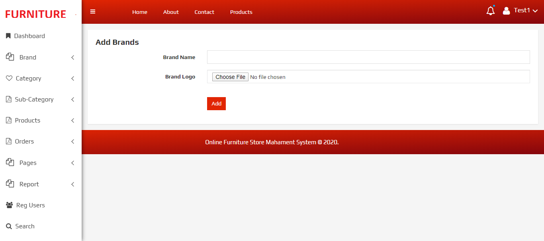
Manage Brands

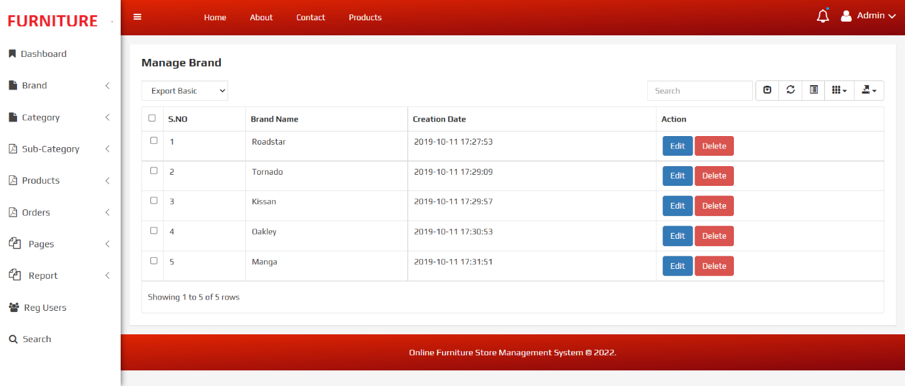

Update Brands

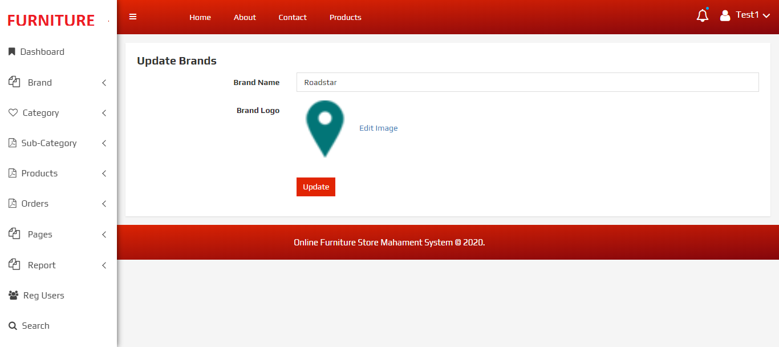
Update Brand Logo
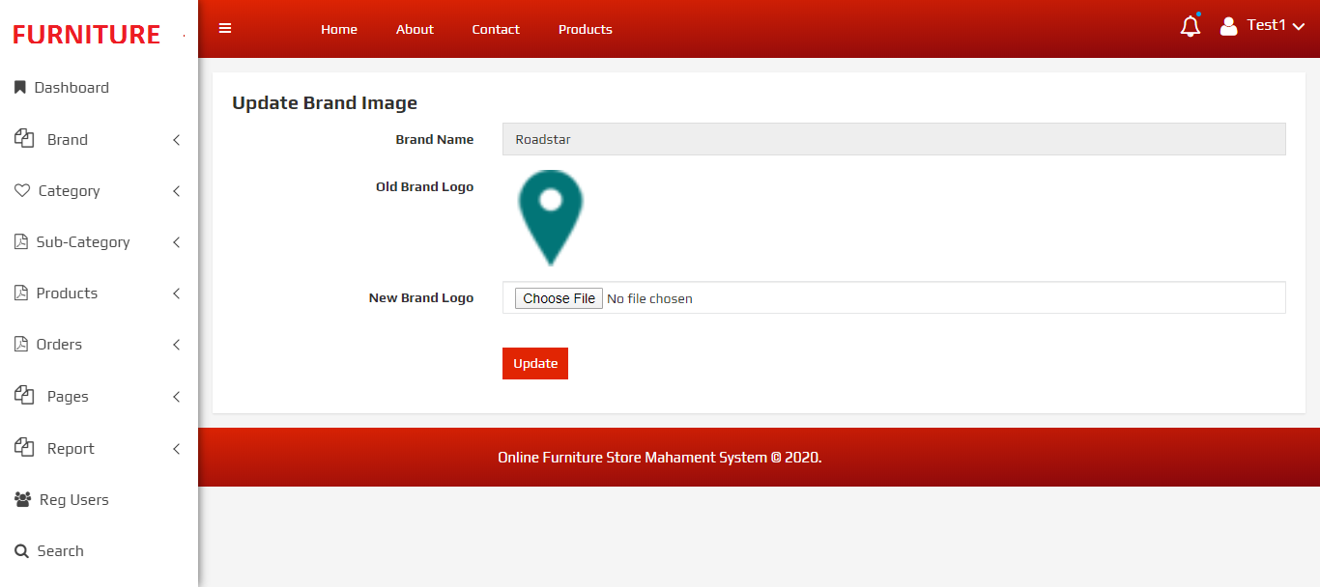

Add Category

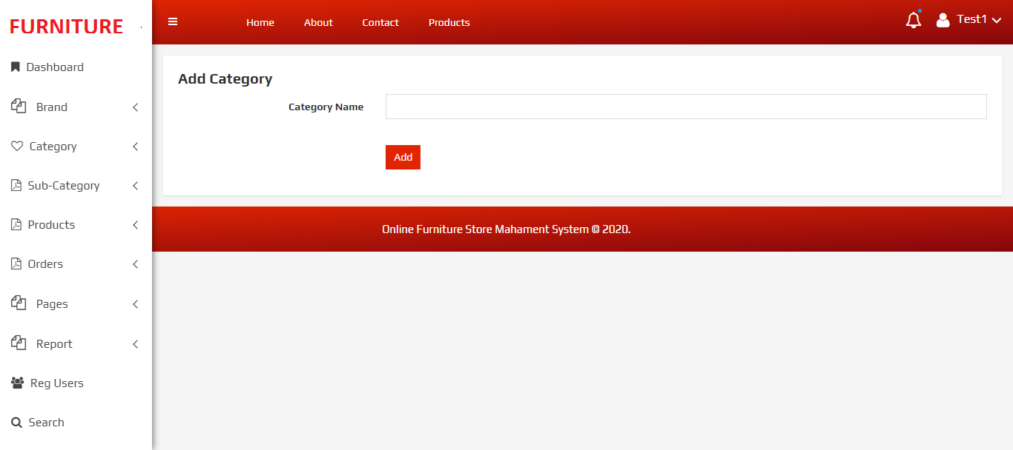

Manage Category

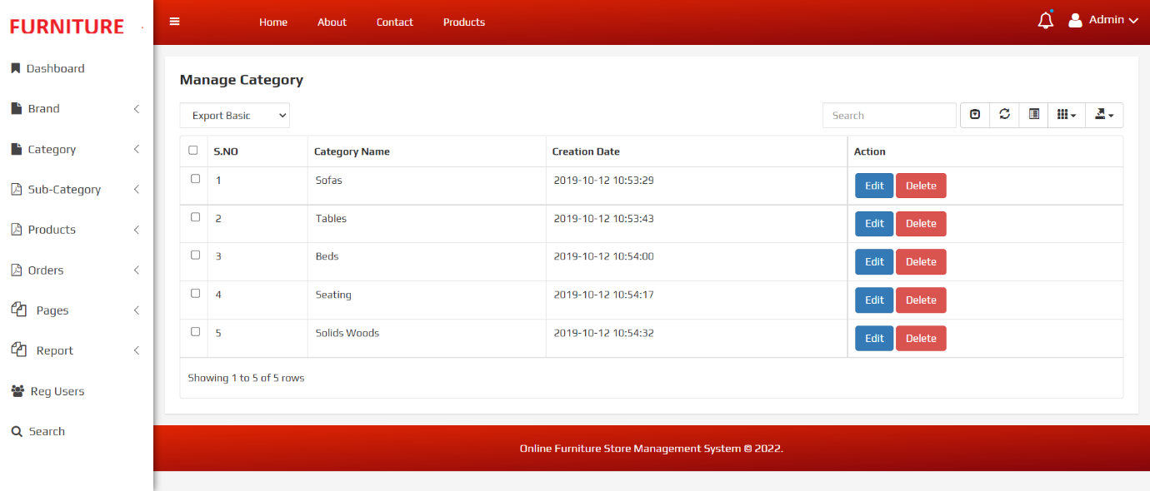

Update Category

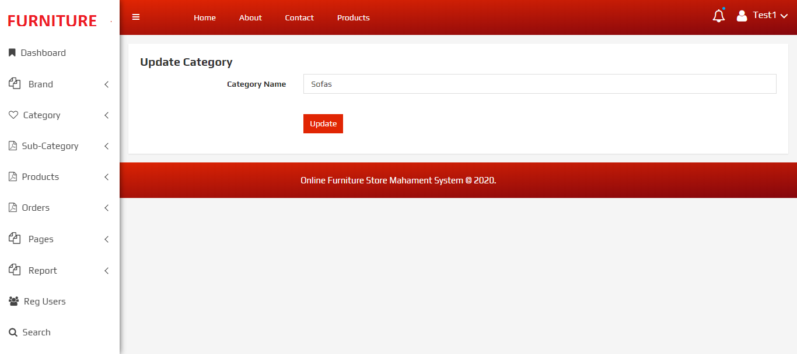

Add Subcategory

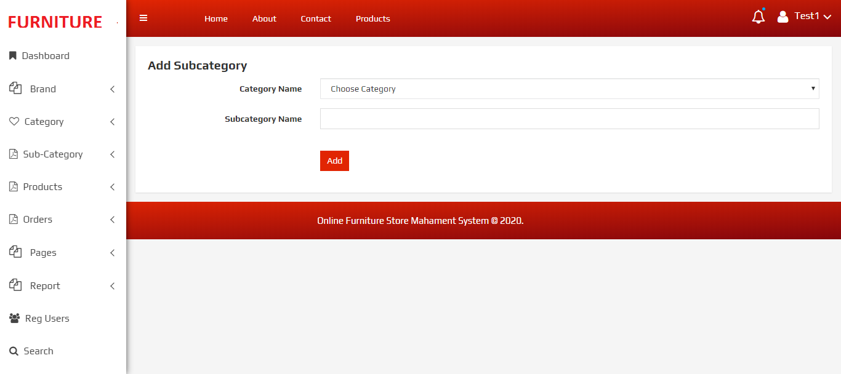

Manage Subcategory

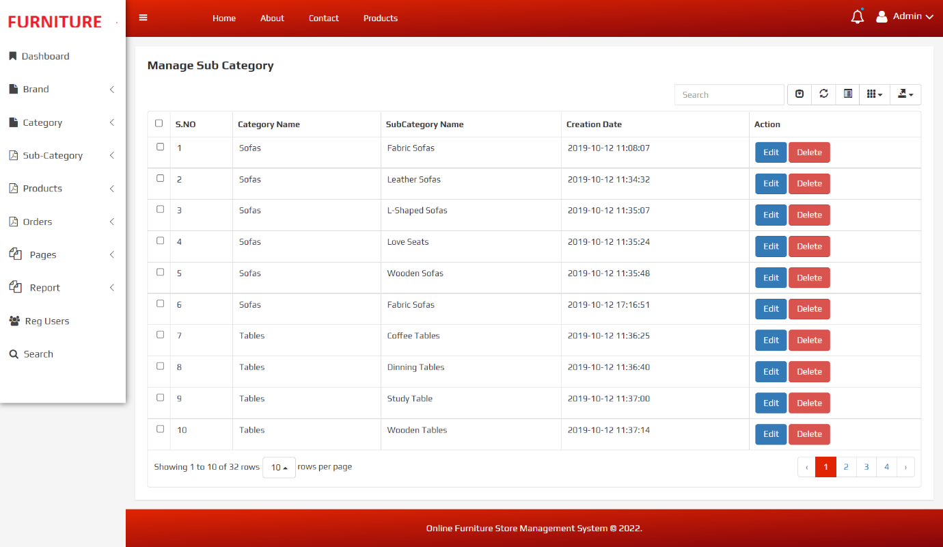

Update Subcategory

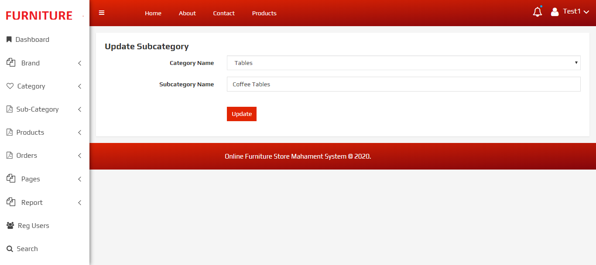

Add Product

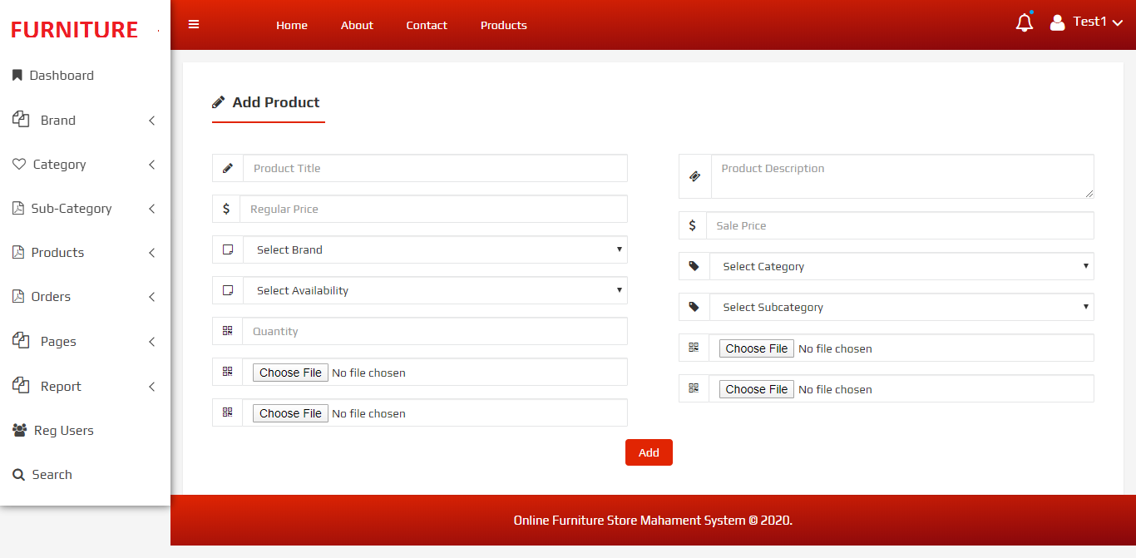

Manage Product

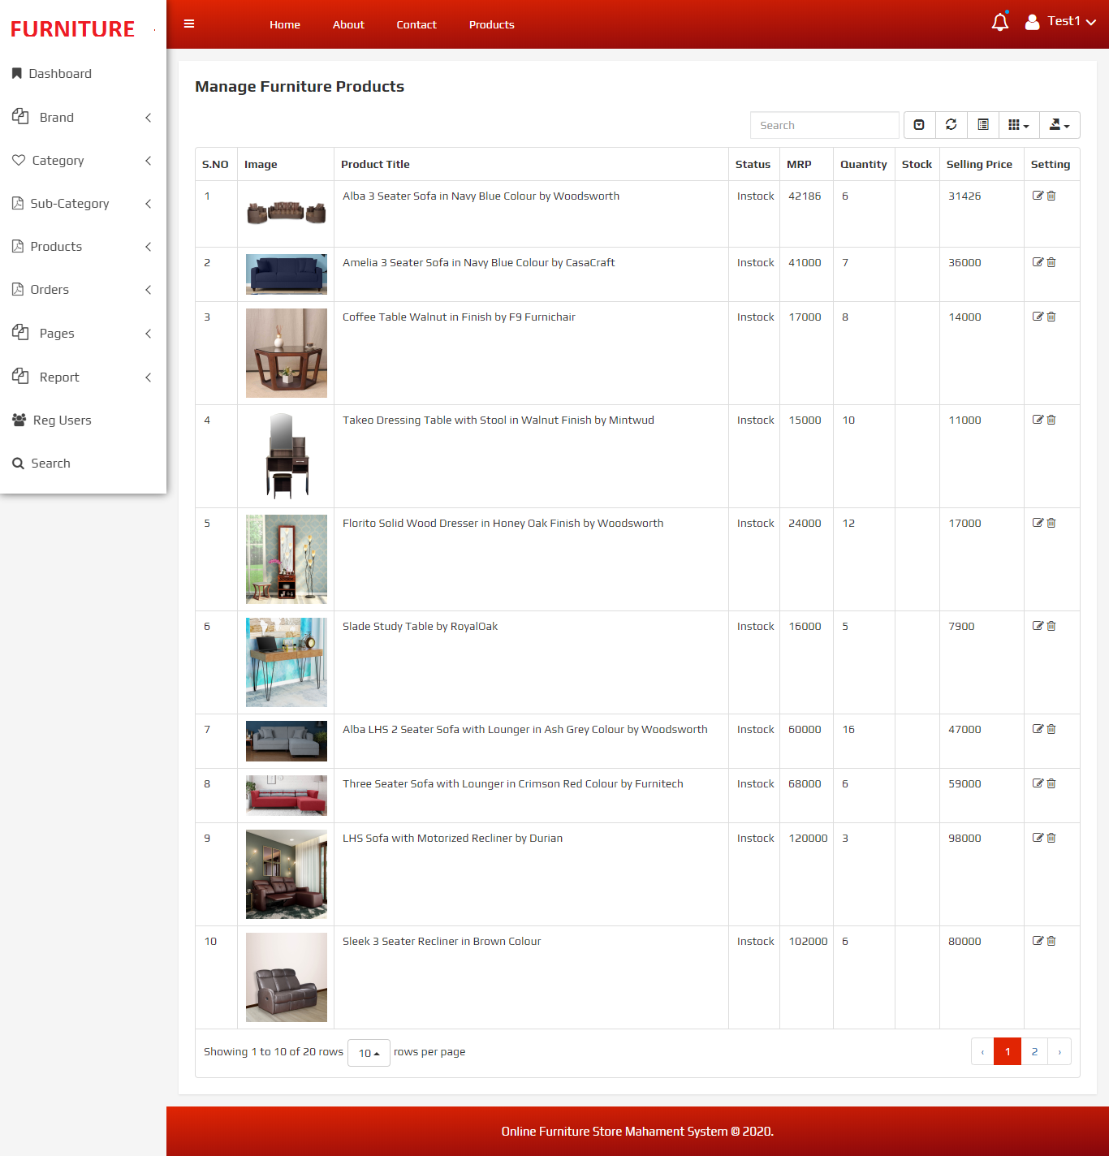

Update Product

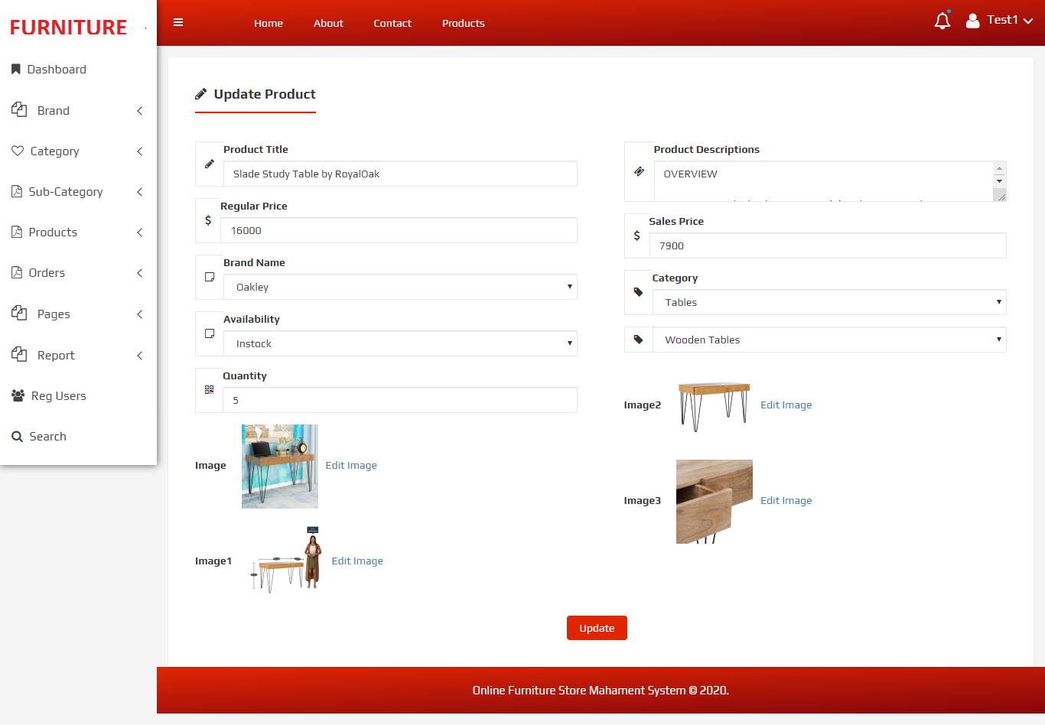

Update Image

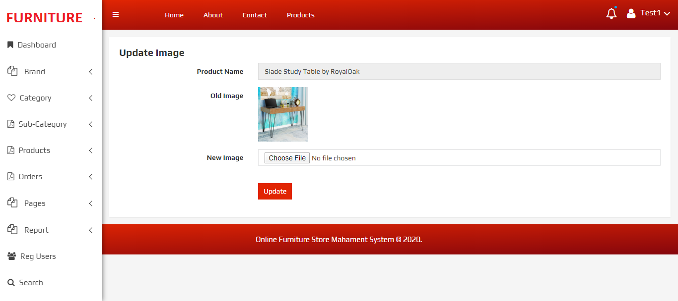

New Order
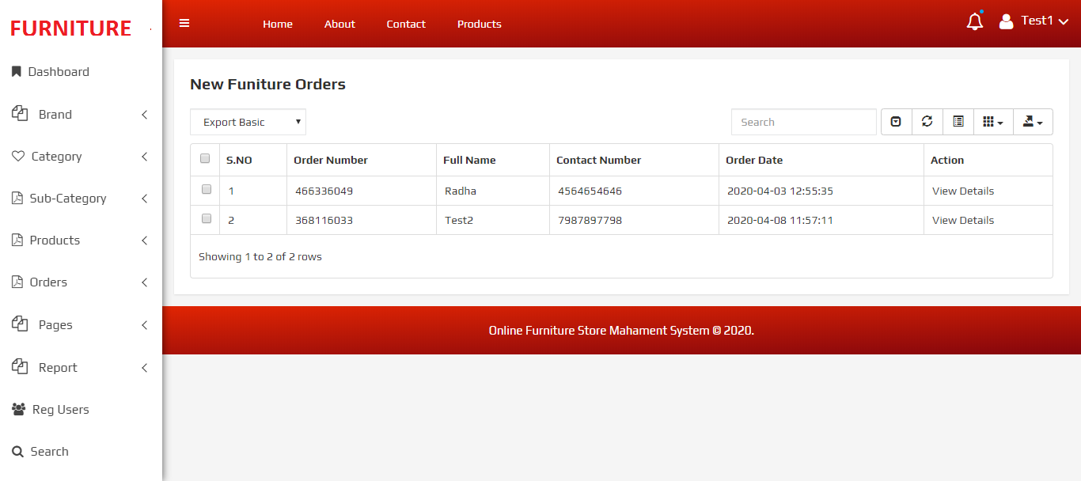

View New Order

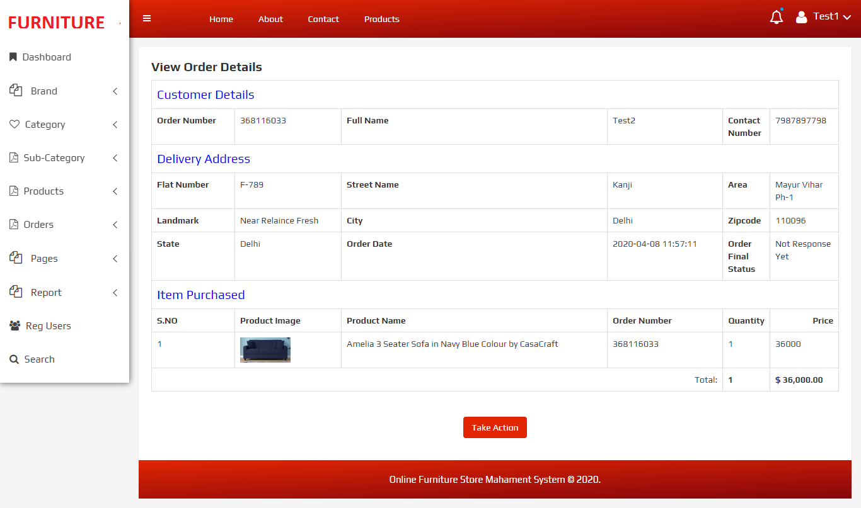

Confirmed Order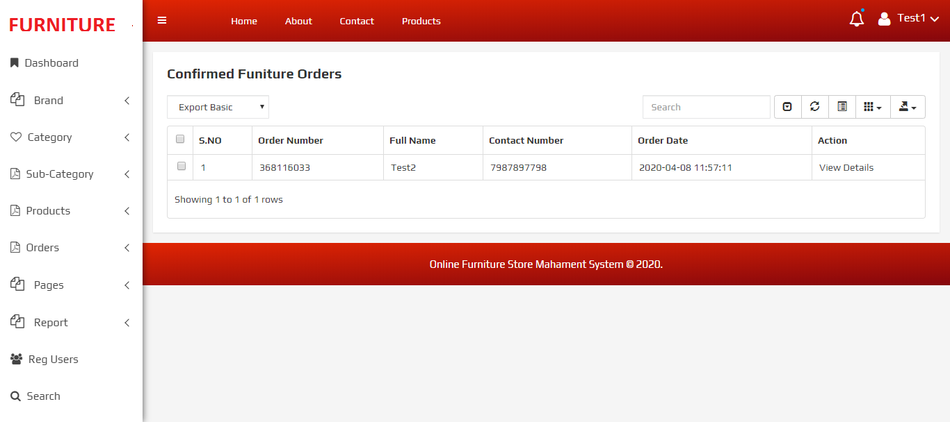

View Confirmed Order

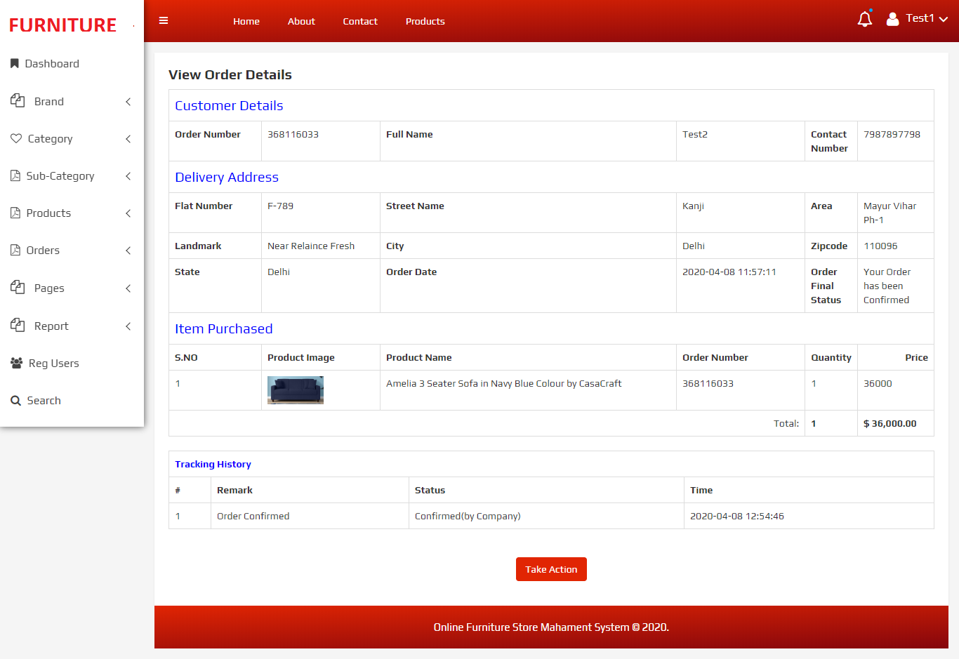

Out for Delivery Orders
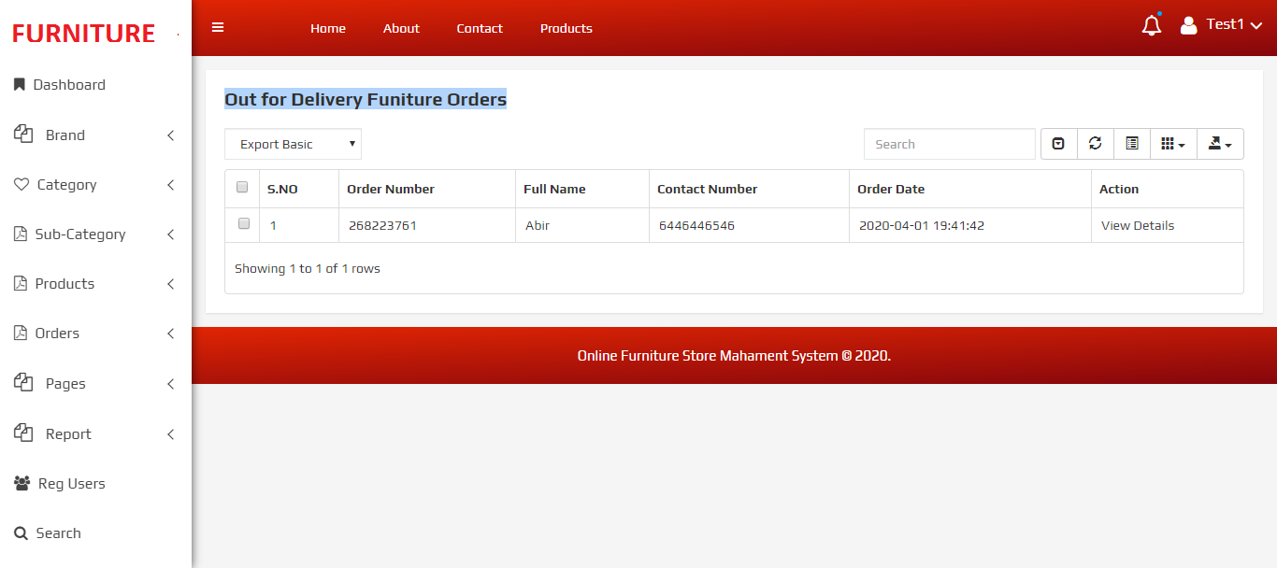

View Out For Delivery Order

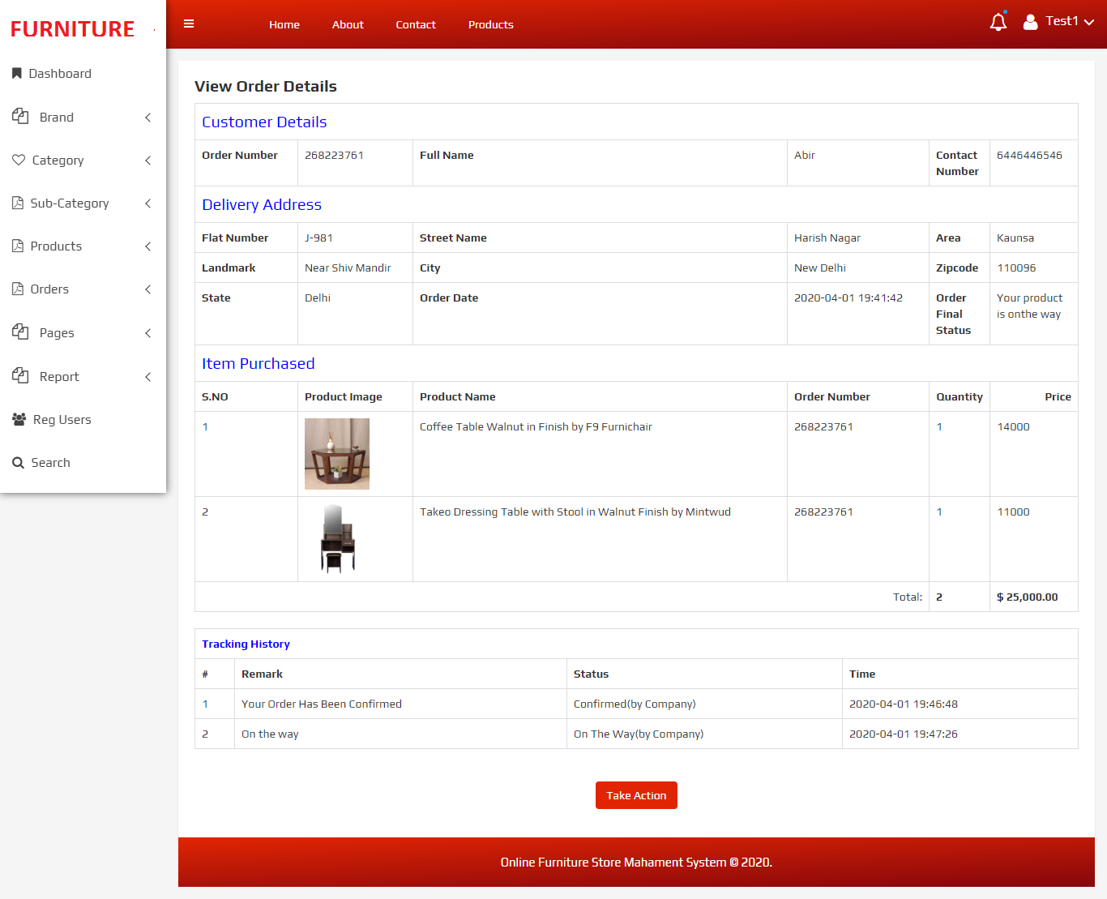

Delivered Order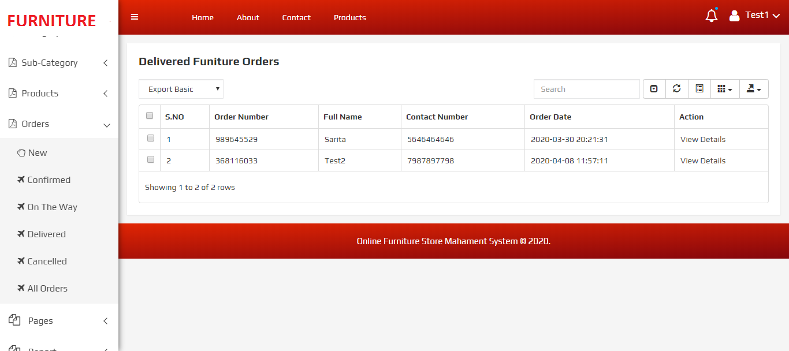

View Delivered Order

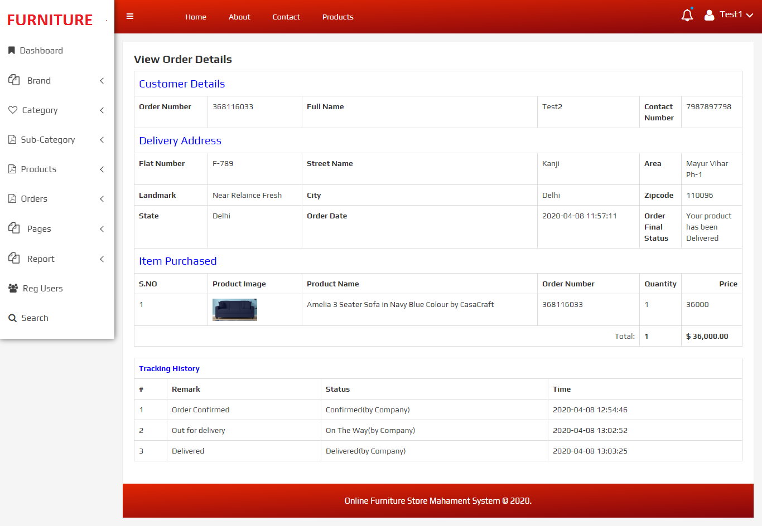

Cancelled Order
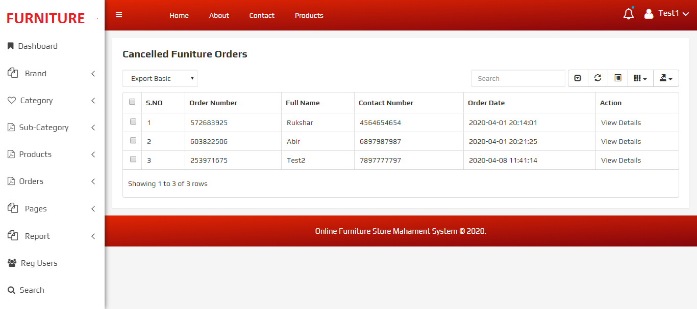

View Cancelled Order

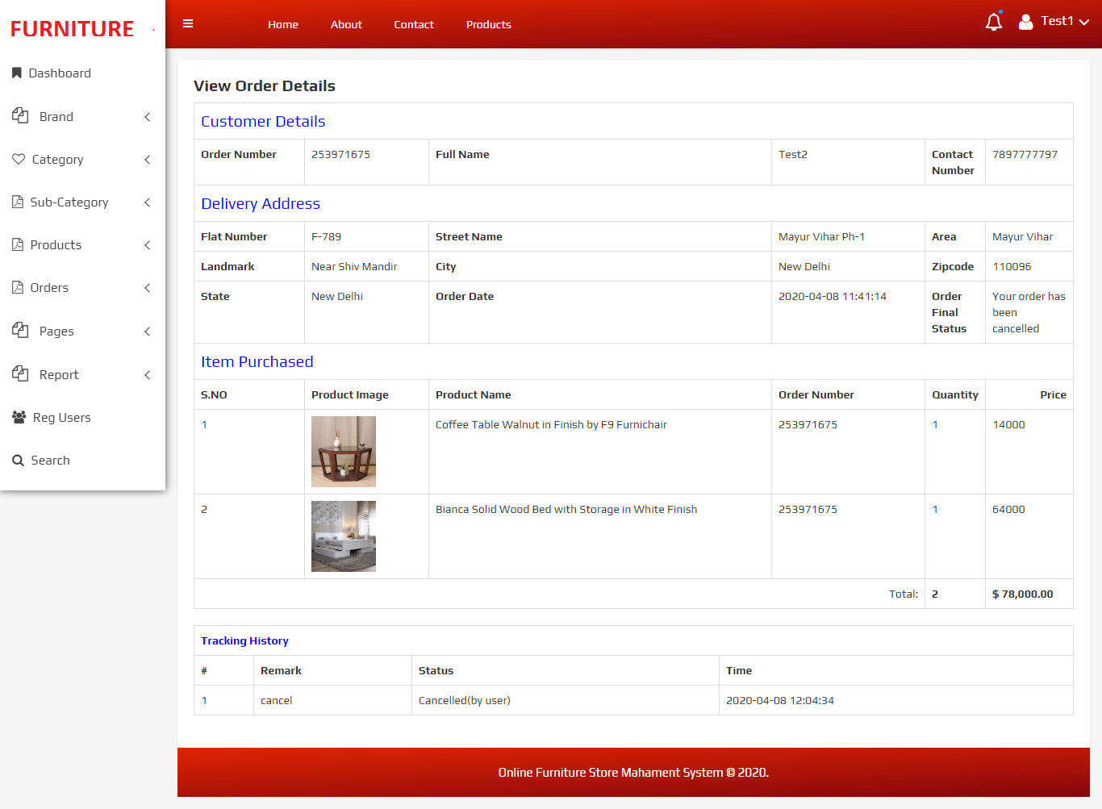

About Us Page
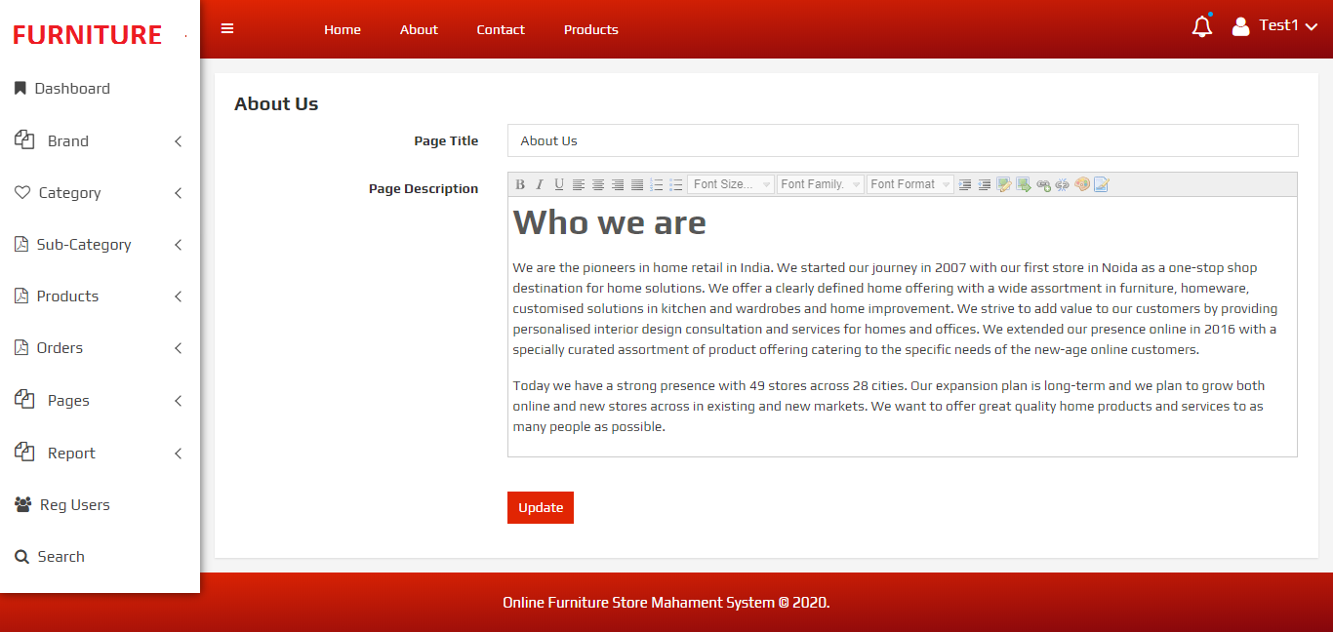

Contact Us Page

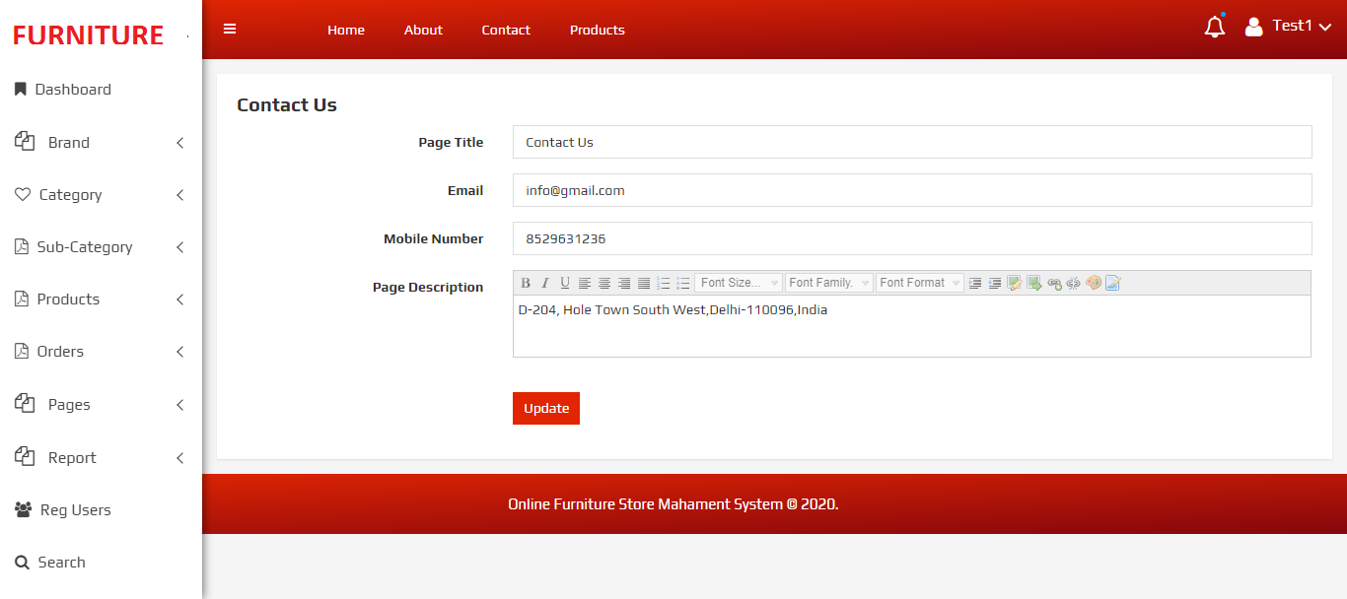

B/W dates Reports

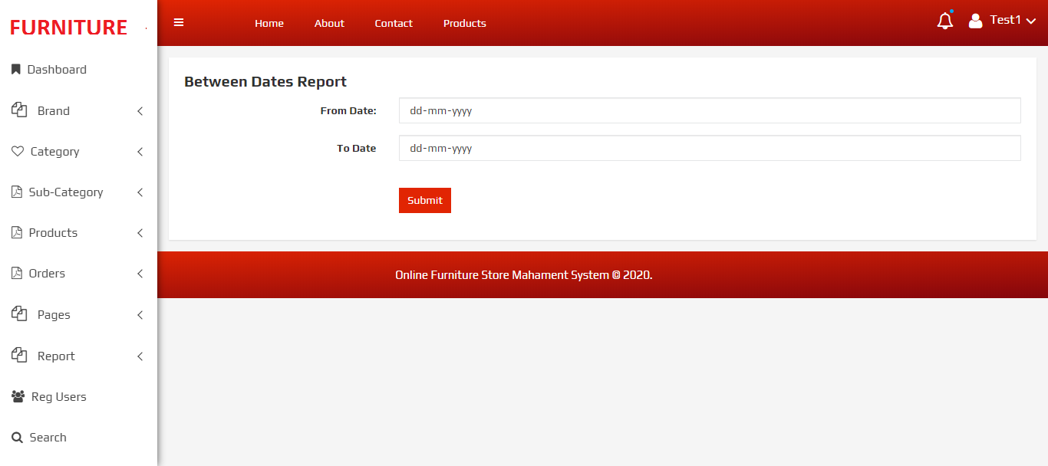

View Details of B/W dates Reports

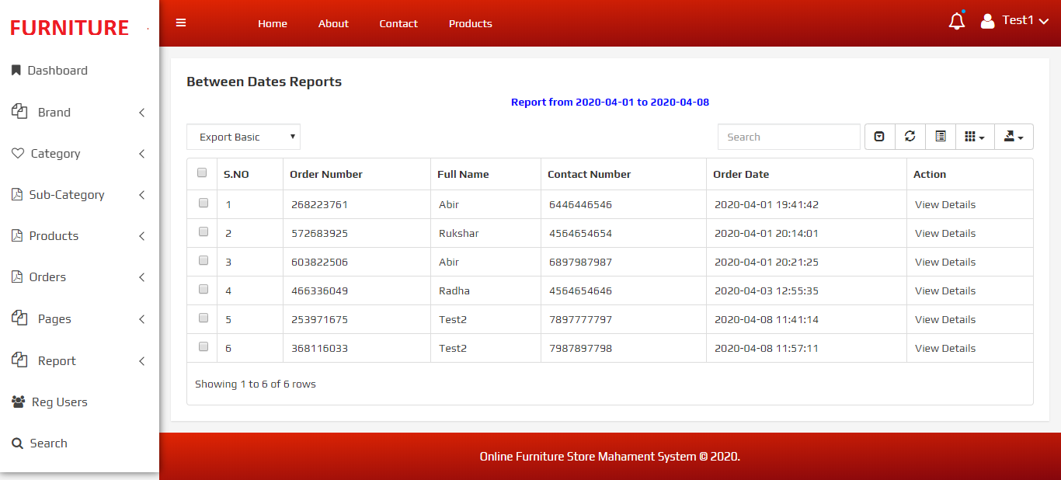

Sales Report

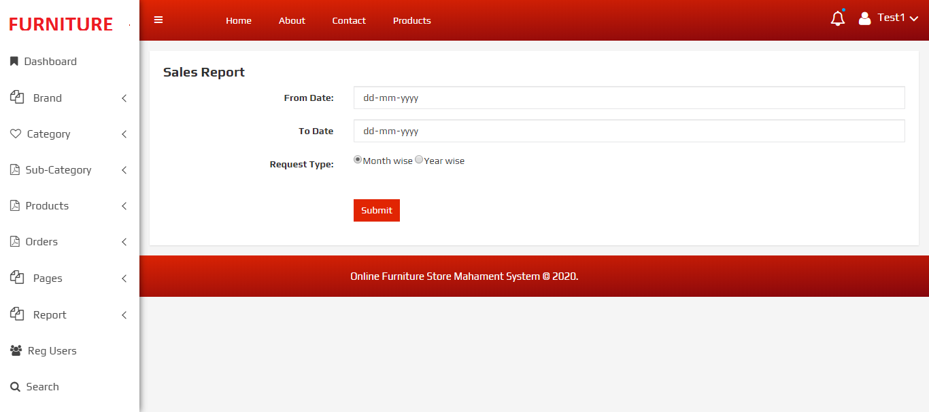

View Sales Report
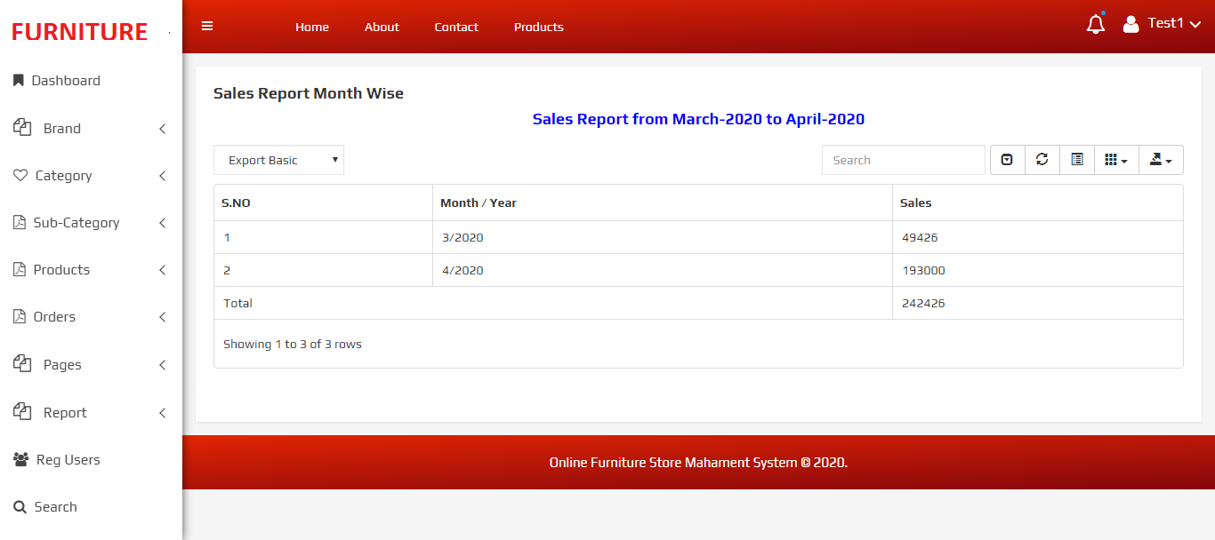

Registered Users

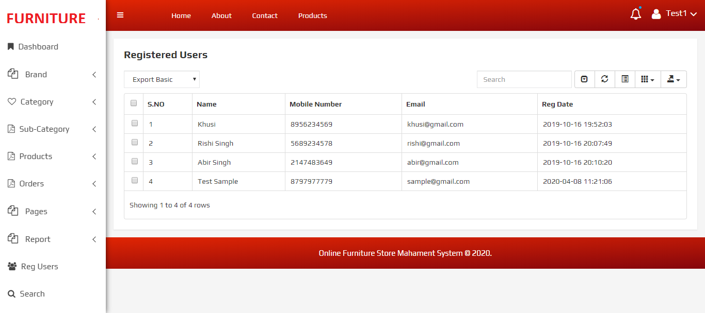

Search Order

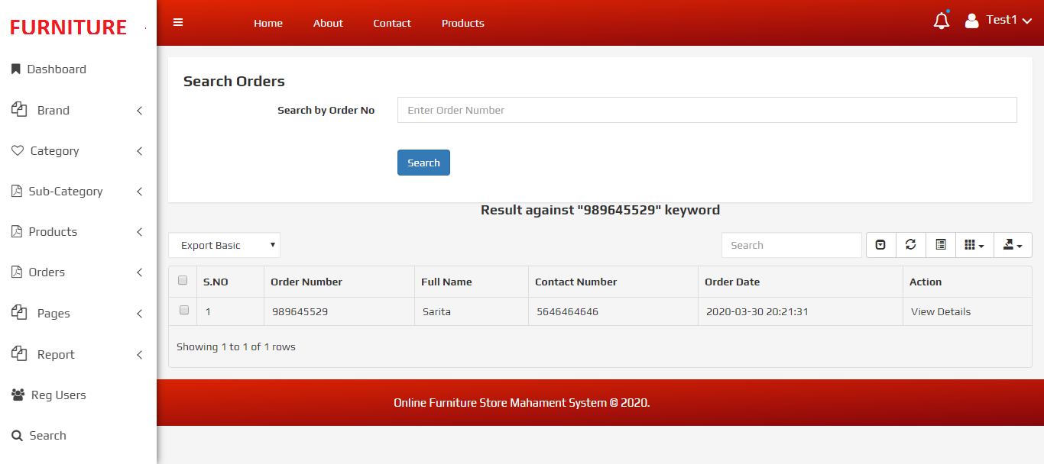

Forgot Password Page

